

**Polling District and Polling Place Review 2025**

**Benwell, Scotswood and Denton Burn Ward**

**Parliamentary Constituency:** Central and West

**(Proposed) Polling Districts:** B01, B02, B03

The Local Government Boundary Commission for England are an independent body accountable to Parliament.  They are responsible for reviewing councils to make sure their patterns of internal wards are fair and sensible.   Their reviews include at least two rounds of public consultation before they make recommendations for change.

The final recommendations were published on 7 January 2025, and the new arrangements apply to local elections from 2026.

As a result of changes to ward boundaries the Acting Returning Officer (ARO) is conducting a review of polling districts and polling places to ensure that they are suitable for the new ward boundaries.

For more information on the local government boundary review visit:  <https://www.lgbce.org.uk/all-reviews/newcastle-upon-tyne>

This document provides details of the review, along with the initial recommendations and comments of the Acting Returning Officer (ARO). Also, the election rules require the ARO to decide how many polling stations are required for each polling station and the ARO must allocate electors to the polling stations in such manner as they think most convenient.

These recommendations will be open to all residents, stakeholders, and any interested parties. We shall be seeking representations from local disability groups on the accessibility and suitability of polling places. Any comments should be addressed in the first instance to pollingplaces@newcastle.gov.uk where they will be collated on behalf of the (Acting) Returning Officer.

We considered the following factors:

* **Identifying new polling places:** We will look for new polling places in areas where the existing provision is unsuitable or unavailable.
* **Feedback:** We will consider feedback received following recent elections, consultation from members of the public, elected members, and other stakeholders.
* **Accessibility:** We will try to ensure that every polling place is accessible to electors with disabilities.
* **Facilities**: We will make sure that all electors have such reasonable facilities for voting as are practicable in the circumstances.
* **Elector numbers:** We will try to comply with the Electoral Commission guidance on the maximum number of electors that should be allocated to a polling station which should not exceed 2,250.
* **Future housing developments**: We will consider the impact of proposed housing developments on polling station electorates.

**(Current) Benwell and Scotswood Ward**

This map shows the current ward and polling district boundaries and the polling places.

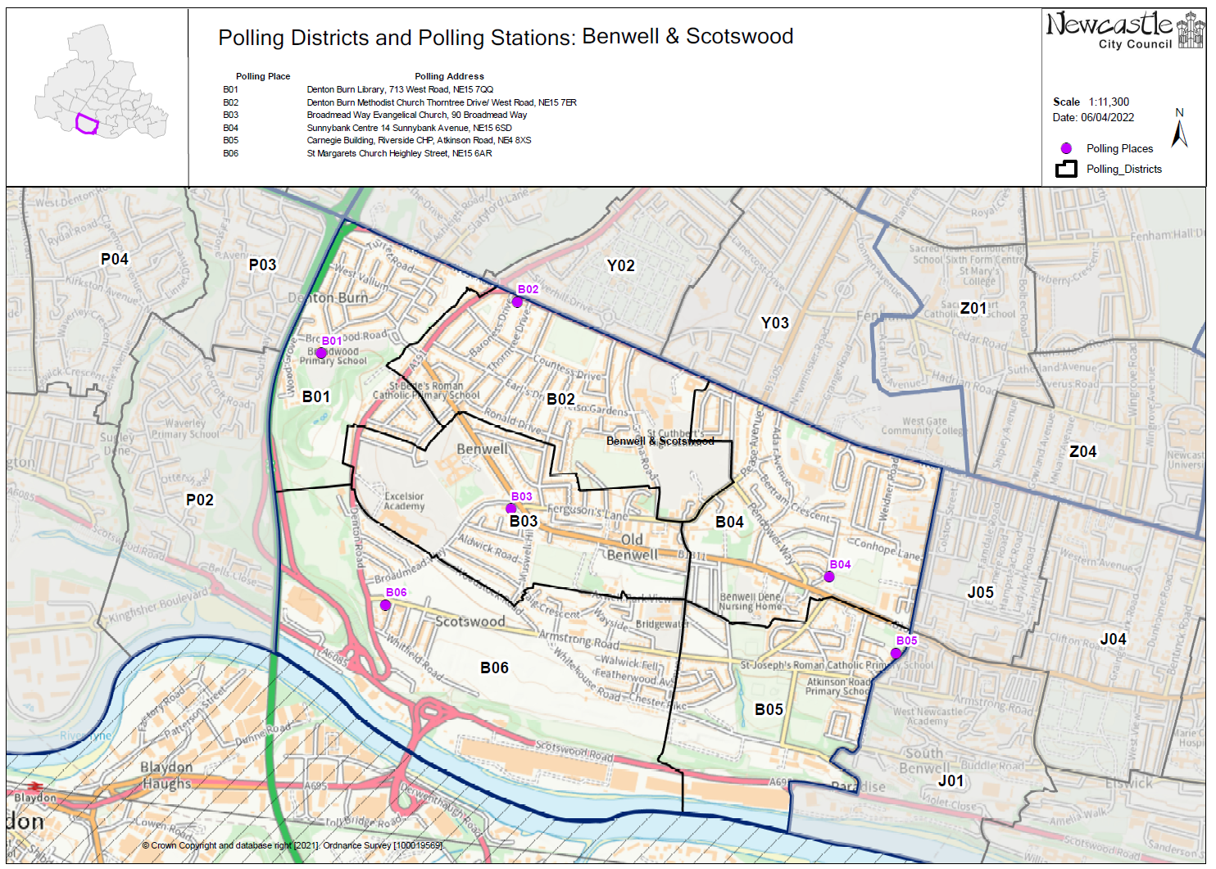

**(New)**

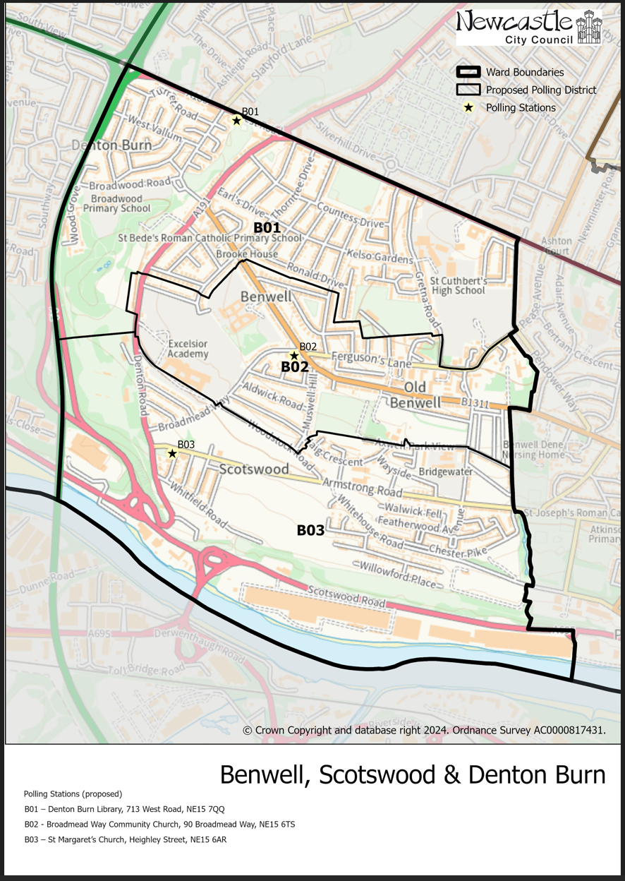**Benwell, Scotswood and Denton Burn Ward**

This map shows the new ward and the proposed polling districts and the proposed polling places.

* **B01**

Denton Burn Library, 713 West Road, NE15 7QQ

* **B02**

Broadmead Way Community Church, 90 Broadmead Way, NE15 6TS

* **B03**

St Margaret’s Church, Heighley Street, NE15 6AL

**Benwell, Scotswood and Denton Burn Ward**

**Polling District B01**

|  |  |  |  |
| --- | --- | --- | --- |
| **Current Polling District** | **Current Polling Place** | | |
| B01 (full)  B02 (full)  B04* (part of) | Denton Burn Library, 713 West Road, NE15 7QQ  Denton Burn Methodist Church, 615-621 West Road, NE15 7ER  Sunnybank Centre, 14 Sunnybank Avenue, NE15 6SD | | |
|  | | | |
| **Proposed Polling District** | | **Predicted Polling Station Electorate** | **Proposed Polling Place** |
| B01 | | 1922 | Denton Burn Library, 713 West Road, NE15 7QQ |
|  | | | |
| **Considerations and Proposals** | | | |
| All of the current B01, B02 and a small part of B04 are merged to create the proposed B01 polling district.  The western boundary of this ward remains unchanged. The boundary line that separates B01 and B02 has been removed. Part of the boundary line between the current B02 and current B04 has also changed. The majority of B04 no longer forms part of Benwell, Scotswood and Denton Burn but now forms part of the Elswick ward. The southern boundary of the current B02 remains unchanged. Part of the eastern boundary line of the current B02 has changed to continue north up Ferguson’s Lane.  Denton Burn Library and Denton Burn Methodist Church are both within the proposed B01 polling district. ARO staff have been unable to identify an alternative building that is more centrally located in the proposed B01 district.  The proposal is to continue using Denton Burn Library. The distance between the two premises is approx. 0.2 miles. | | | |
|  | | | |
| **Preliminary Consultation – Elected Members comments and feedback** | | | |
| **Cllr Stephenson:**  “I would suggest retaining Denton Burn Methodist Church for the Thorntree Estate from Denton Road upwards and extending its use to accommodate more areas up the West Road to the new Boundary. It is accessible for all as is Denton Burn library further down the West Road, for the Broadwood Estate down to Wood Grove. A lot of elderly who like to vote on the Thorntree Estate and use the church. As well as on Broadwood Estate. Both should be retained to reflect that.” | | | |

**Benwell, Scotswood and Denton Burn Ward**

**Polling District B02**

|  |  |  |  |
| --- | --- | --- | --- |
| **Current Polling District** | **Current Polling Place** | | |
| B03 (full)  B04 (part of) | Broadmead Way Community Church, 90 Broadmead Way, NE15 6TS  Sunnybank Centre, 14 Sunnybank Avenue, NE15 6SD | | |
|  | | | |
| **Proposed Polling District** | | **Predicted Polling Station Electorate** | **Proposed Polling Place** |
| B02 | | 999 | Broadmead Way Community Church, 90 Broadmead Way, NE15 6TS |
|  | | | |
| **Considerations and Proposals** | | | |
| All of the current B03 is merged with a small part of the current B04 to create the proposed B02 polling district.  The western boundary that separates the current B02 and B01 remains unchanged. The current southern boundary line is mostly unchanged. A small section of the current B04 forms part of the proposed B02 district. The southern boundary of the proposed B02 district would continue along Axwell Park View.  Alternative premises have been considered within the proposed B02 district. Whilst there are no issues with Broadmead Way Community Church, this review provides the ARO with the opportunity to consider other premises within the district.  ARO staff contacted Excelsior Academy to see if they would consider being used as a polling place, to which they were happy to be considered. A site visit was conducted in July 2025 to check if the building meets accessibility requirements and if the building would be a suitable choice for a polling station. The outcome of the site visit was positive, however, taking into consideration the comments from Councillor Stephenson, the decision was made to continue the use of Broadmead Way Community Church in the district. | | | |
|  | | | |
| **Preliminary Consultation – Elected Members comments and feedback** | | | |
| **Cllr Stephenson:**  “Access to Excelsior is difficult without a car due to the steep incline from Denton Road. It has never been used before due to this, and we had to move away from using schools for security safeguarding and space and security issues. I therefore suggest retaining St Margaret’s Church on Heighley Street.” | | | |

**Benwell, Scotswood and Denton Burn Ward**

**Polling District B03**

|  |  |  |  |
| --- | --- | --- | --- |
| **Current Polling District** | **Current Polling Place** | | |
| B06 (full)  B05 (part of) | St Margaret’s Church, Heighley Street, NE15 6AR  Carnegie Building, Atkinson Road, NE4 8XS | | |
|  | | | |
| **Proposed Polling District** | | **Predicted Polling Station Electorate** | **Proposed Polling Place** |
| B03 | | 1199 | St Margaret’s Church, Heighley Street, NE15 6AR |
|  | | | |
| **Considerations and Proposals** | | | |
| All of the current B06 is merged with a small part of the current B05 to create the proposed B03 district.  The current B06 is largely unchanged with only the eastern boundary between B06 and B05 changing. The new ward boundary now replaces the polling district boundary. The ward boundary continues along Willowford Place (past waste land) until the road meets Whitehouse Road, continues through Hodgkin Park, over Armstrong Road to join Milford Road.  Due to significant change to the ward boundary, Benwell, Scotswood and Denton Burn ward no longer incorporates a large part of the current B04 and current B05. These now form part of the new Elswick ward.  Bridgewater Primary School was considered as a possible station to serve the proposed district of B03 as it is in a well populated area.  This building is also likely to be more cost effective. ARO staff have made a visit to the school on 8 July 2025, and it was concluded that the school would not be a suitable option.  The proposal is to continue using St Margaret’s Church as this previously served some of the same electors (current B06). | | | |
|  | | | |
| **Preliminary Consultation – Elected Members comments and feedback** | | | |
| **Cllr Stephenson:**  “Bridgewater School - a lot of older people could not easily access that, therefore suggest retaining St Margaret’s Church in Heighley Street.”  **Response:**  Comments from Cllr Stephenson noted.  Bridgewater School wasn’t a workable option following a site visit. | | | |

THIS PAGE IS INTENTIONALLY BLANK